Assignment

## Student Name: Nihaal Tayob

## Student ID:M00738443

Design in **Multisim** a full 4-bit binary numbers adder/subtractor circuit, with a switch to swap between arithmetic operations. Utilise your knowledge of electronics to build your circuit using the **ONLY** following IC’s:

·         1 Full adder IC 74283

·         2 Quad 2 Input AND gats SN74HC08

·         1 Quad 2 Input OR gats SN74HC32

·         2 Hex Inverting gates DM7404N

You have one week to design your circuit. You will demonstrate how it works. In the lab session you will be given 4 different arithmetic operations on the spot.

* Show your steps in designing your circuit. Use this word document to submit your answer with the steps of your design *(20 marks)*.
* Take a screenshot of your final design *(5 marks).*
* Specify the number of gates you used in your design *(5 mark)*.
* Explain how your Control switch works to change between the arithmetic operations *(5 mark)*
* Demonstrate how your design circuit work to your tutor, displaying the arithmetic operations *(4 marks)*
* Finally, what will you adjust to your design to make it more effective (Hint: replacing gates) *(1 mark)*.

Answer

## Your design:

1. To fully understand the context of the 4-bit binary number adder/subtractor circuit and what was required of me to design this circuit, I constructed a research report in which a gained all the information i needed in order to go about the task.
2. I then drew a rough draft to determine what components i needed and where to place them in order to make the circuit work
3. I initially used a XOR gate approach, but upon realising we could only make use of AND, OR and NOT gates I needed a new approach. I used my knowledge learned about truth tables to determine which gates would give me the same or similar results to the XOR gate. The gates that stood out to me after constructing the various truth tables, keeping in mind the constraints, were the NAND and the OR gates. Attached below are the truth tables I constructed during this step.
4. I used the above gates to construct the circuit, using 2 NOT gate and 2 AND gates to form the NAND gates and combined them using the OR gate. I attached below the Bill of Materials drawn up by Multisim about my circuit.
5. I then drafted my circuit on Multisim using the following steps:

* I made use of interactive digital constants as the inputs, I added 4 A inputs, 4 B inputs (as we are creating a 4 bit binary number circuit) and 1 more as a Cin as the carry(the control line).
* I used 4 LEDS to stand as the output, and 1 more LED as we needed a Cout as the carry output, due to 2s complement when subtracting. I also connected the output components to ground
* I used a main IC(4 BIT FULL ADDER WITH FAST CARRY) and connected A’s inputs directly to it
* I connected B’s input as well as Cin and connected it to the appropriate gates. I connected the various gates to a 5v on page connector power source as well as the ground. The one AND gate is connected with the complement of B’s input by making use of the NOT gate, the other AND gate is connected with the complement of Cin also with the use of a NOT gate. Both the AND gates results are connected to an OR gate.
* I connected the result for the last gate, which is the OR gate, to determine B’s input to the main IC, as well the Cin.

1. I tested the circuit by adding various 4-bit binary values as A and B. To make use of the adder, Cin needs to be 0. To make use of the subractor , Cin needs to be 1.
2. The result achieved was what I determined it to be. The results are showed with the use of the red LED’s. When the LED is lit up it is a 1, when it does not light up it is a 0. We then read the result from there. Cout is 1 when subtracting due to 2s complement. Therefore the outputs produced are the sum/difference as well as the carry.

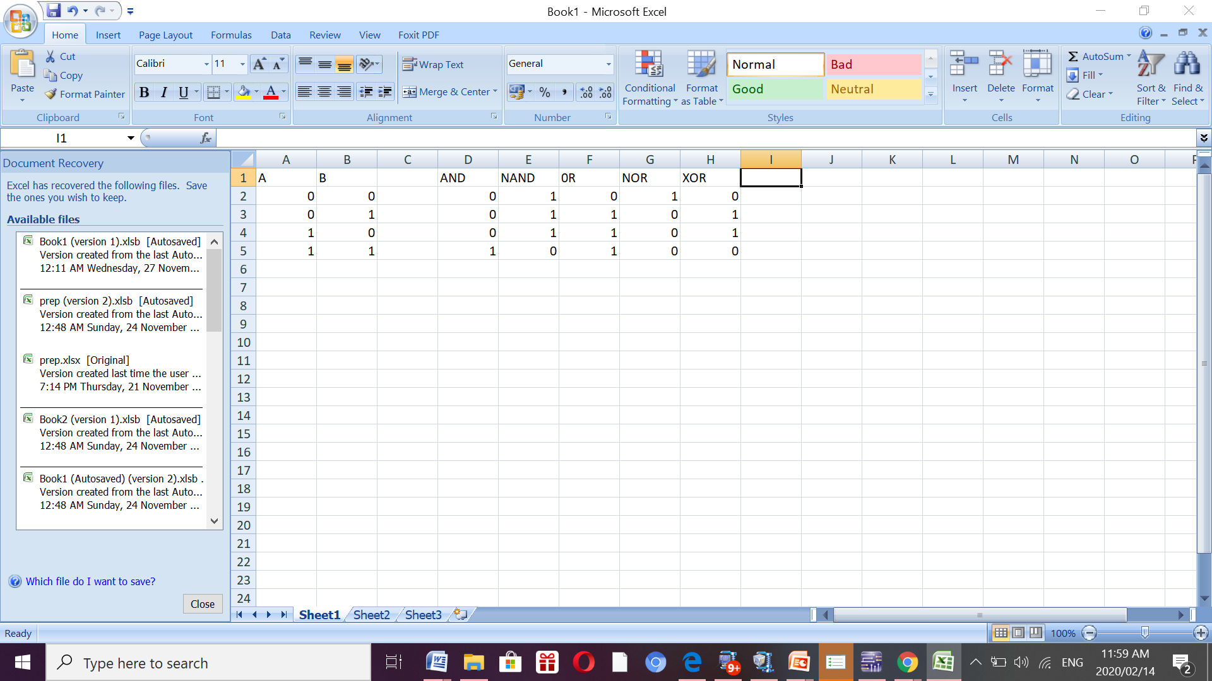

TRUTH TABLE

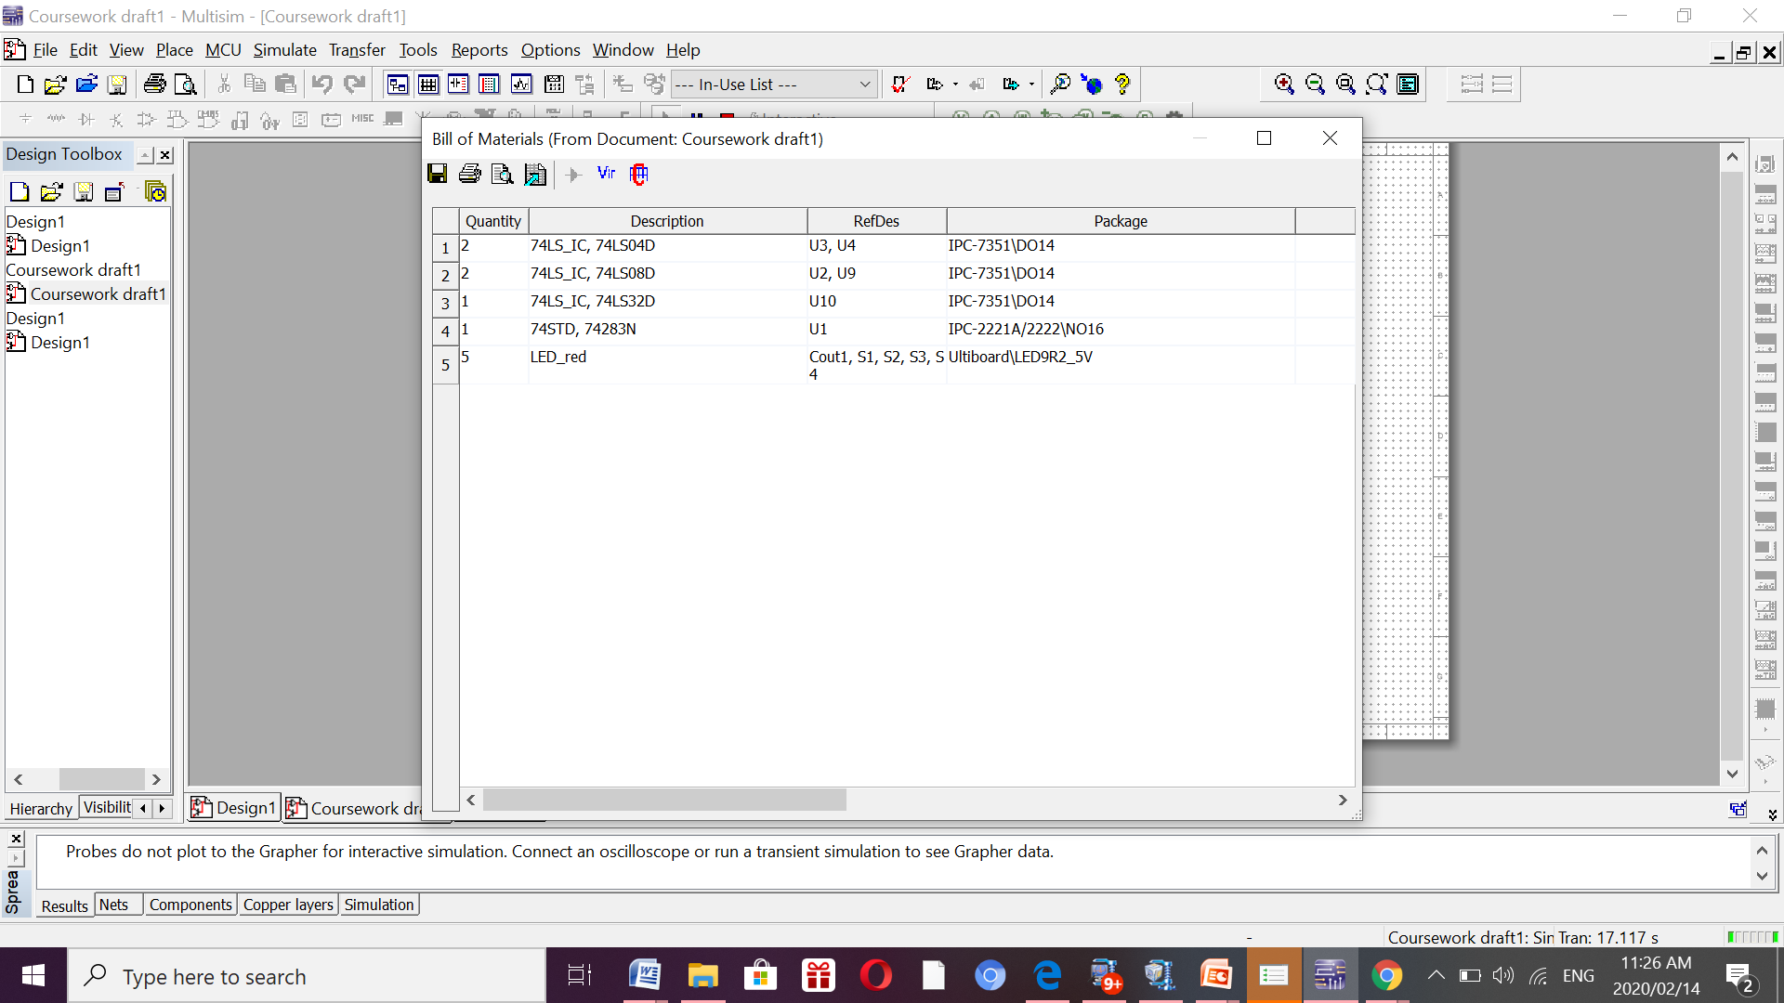

BILL OF MATERIALS

……………………………………………………………………………………………………………………………………………………………………...

…………………………………………………………………………………………………………………………………………………………………………………………………………………………………………………………………………………………………………………………………………………………………………...

…………………………………………………………………………………………………………………………………………………………………………………………………………………………………………………………………………………………………………………………………………………………………………...

…………………………………………………………………………………………………………………………………………………………………………………………………………………………………………………………………………………………………………………………………………………………………………...

…………………………………………………………………………………………………………………………………………………………………………………………………………………………………………………………………………………………………………………………………………………………………………...

…………………………………………………………………………………………………………………………………………………………………………………………………………………………………………………………………………………………………………………………………………………………………………...

…………………………………………………………………………………………………………………………………………………………………………………………………………………………………………………………………………………………………………………………………………………………………………...

…………………………………………………………………………………………………………………………………………………………………………………………………………………………………………………………………………………………………………………………………………………………………………...

…………………………………………………………………………………………………………………………………………………………………………………………………………………………………………………………………………………………………………………………………………………………………………...

…………………………………………………………………………………………………………………………………………………………………………………………………………………………………………………………………………………………………………………………………………………………………………...

…………………………………………………………………………………………………………………………………………………………………………………………………………………………………………………………………………………………………………………………………………………………………………...

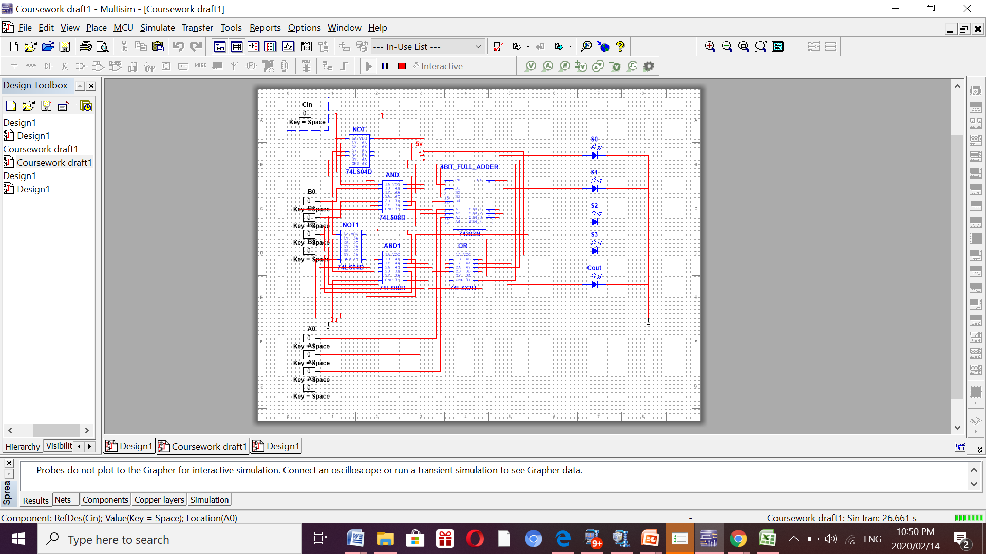



## How many gates did you used in your design:

## And Gate: 8 AND Gates, 2 Quad 2 input AND gates(IC)

## OR Gate: 4 AND Gates, 1 Quad 2 input OR gate(IC)

## NOT Gate:8 NOT Gates, 2 Hex Inverting gates



## How you control your design in switching between your arithmetic operations:

To control my design between switching between arithmetic equations, I made use of the control line (Cin). When its value is 1, B’s output is complement to get the result for subtraction, as the equation changes to A+B’ because of 2s complement. When its value is 0, the equation of A+B is used, therefore the arithmetic operation is addition.

